**VietSpider Quick Guide – Step by Step – create channel by Channel Store**

1. **Launch VietSpider**

Goto **VietSpider** folder and double click on **VietSpider.exe**

1. **Open Channel Store**

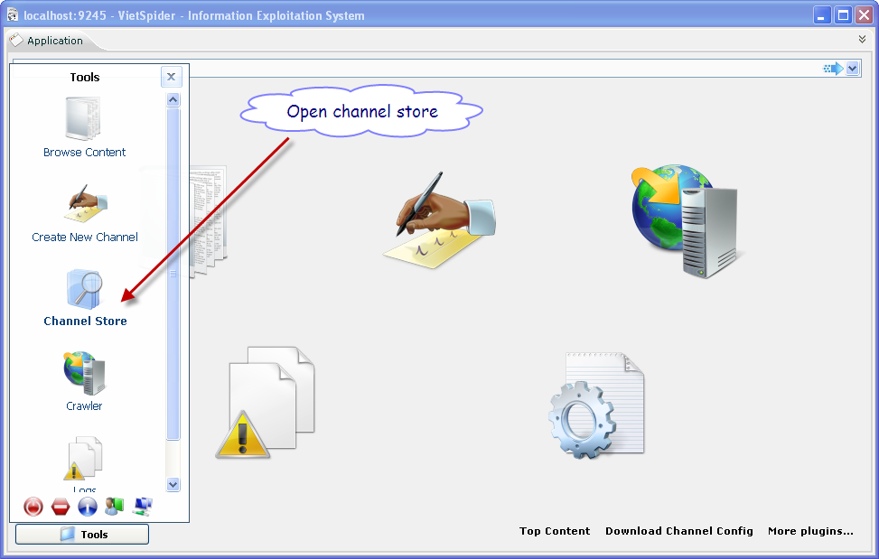

Select **Tools** -> **Channel Store**

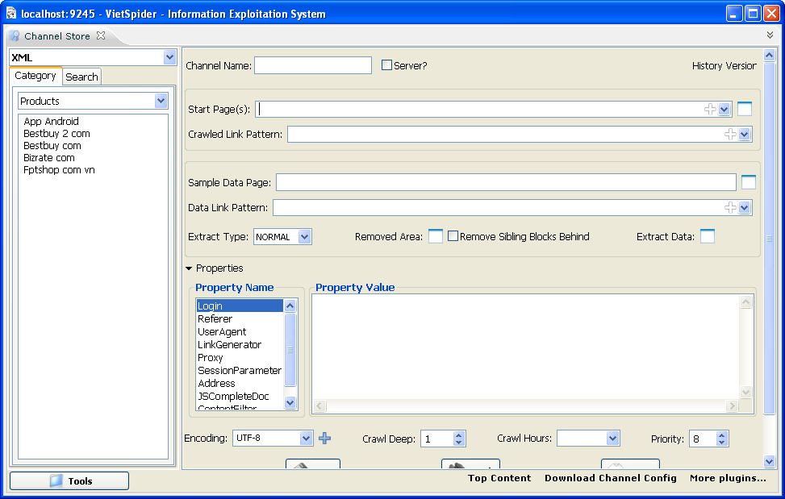

1. **Add Start Page(s)**

Browse the website by your browser

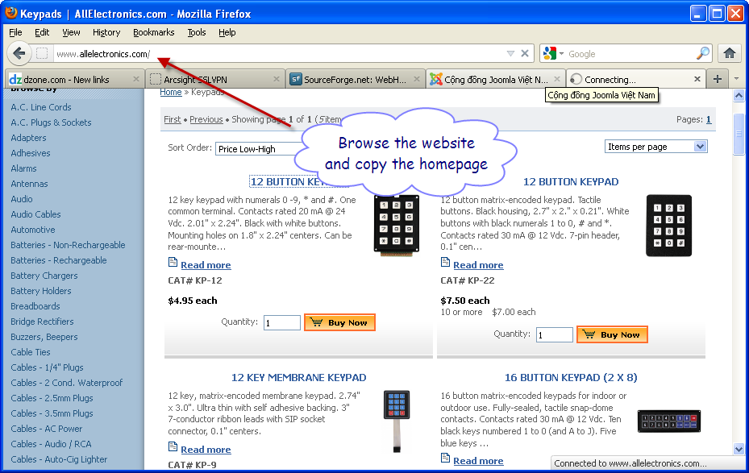

And copy the home page

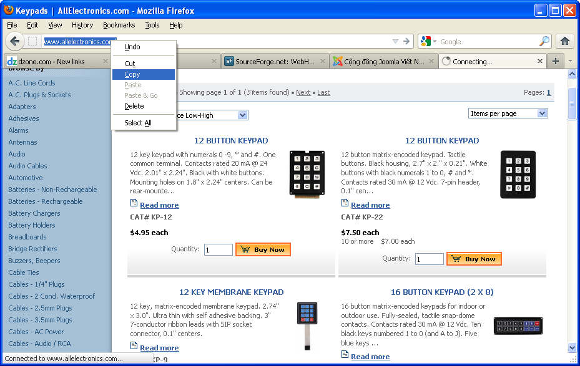

Paste the home page to **Start Page** field

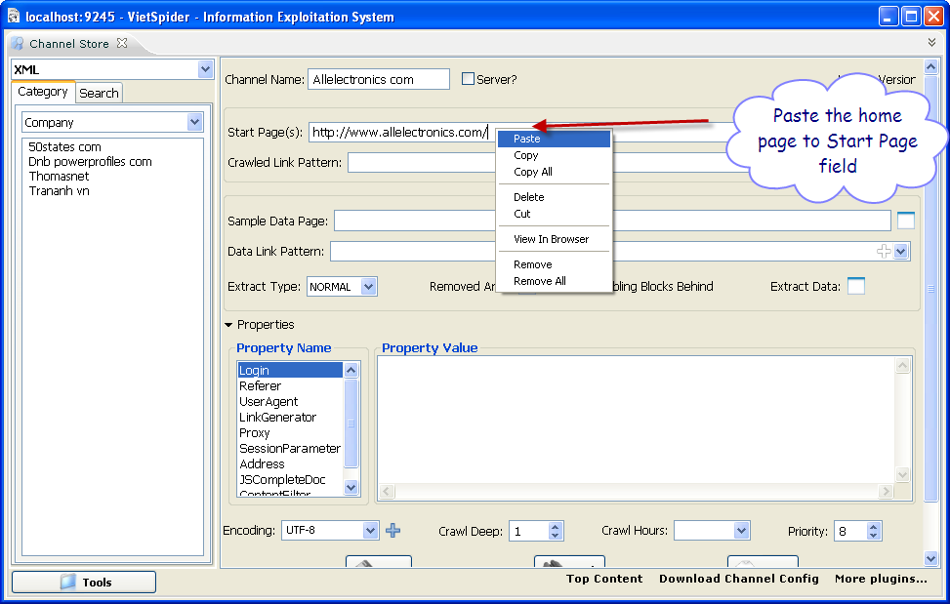

1. **Input Sample Data Page**

Back to **Web Browser** and copy a data link

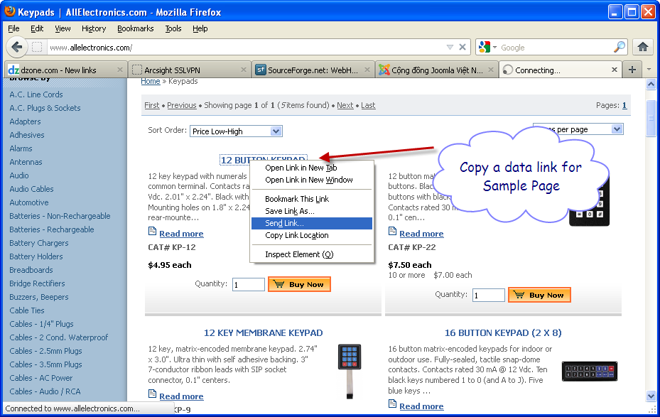

And paste to **Sample Data Link**

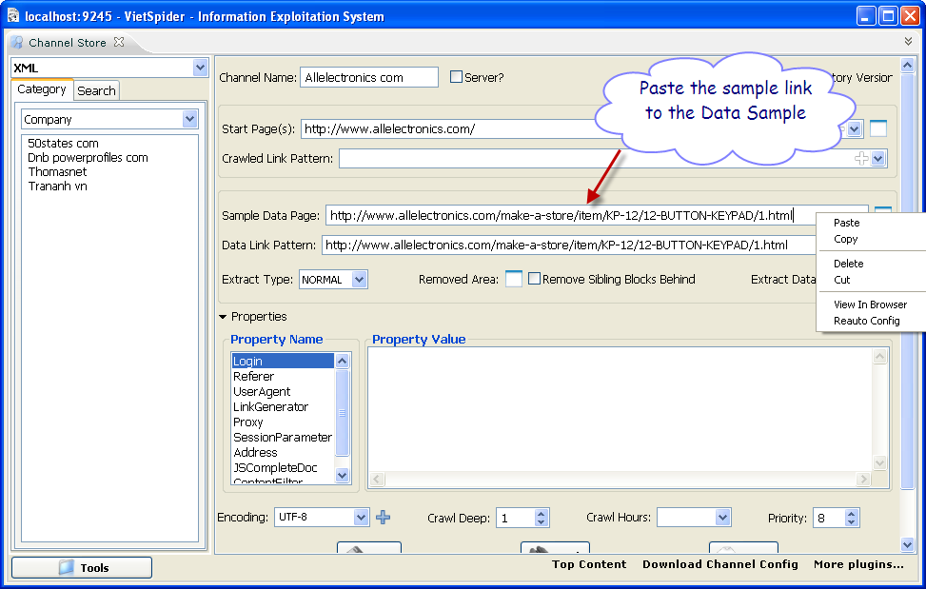

1. **Make Data Link Pattern**.

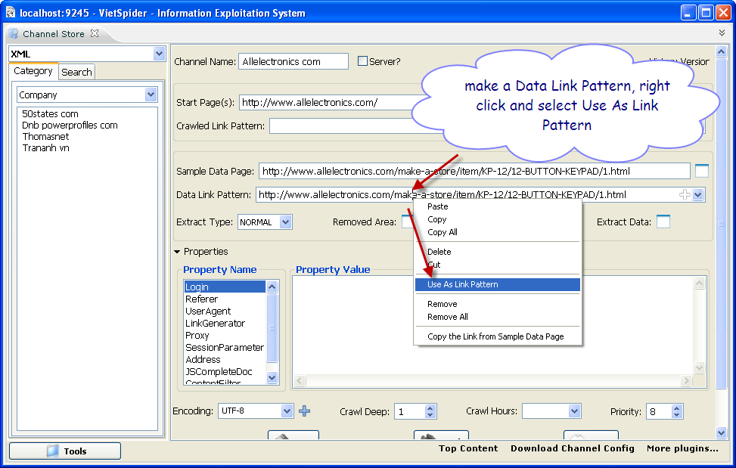

Focus to the appropriate location in the **Data Link Pattern** field, right click and select **Use as Link Pattern**.

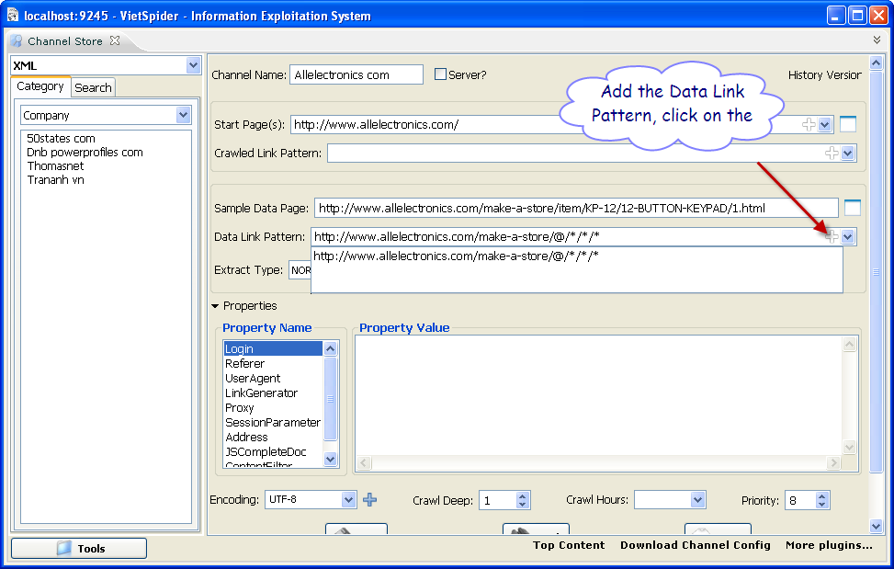

Click on add icon to add url pattern to the list.

1. **Define extract area on the Sample Data Page**.

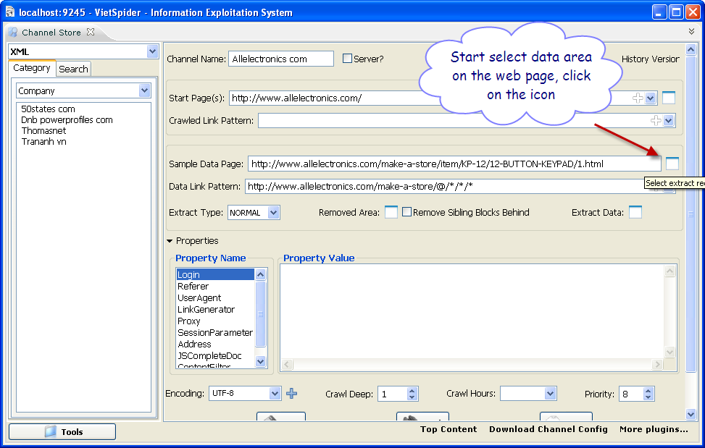

Click the icon is right at the end of the **Sample Data Page** field.

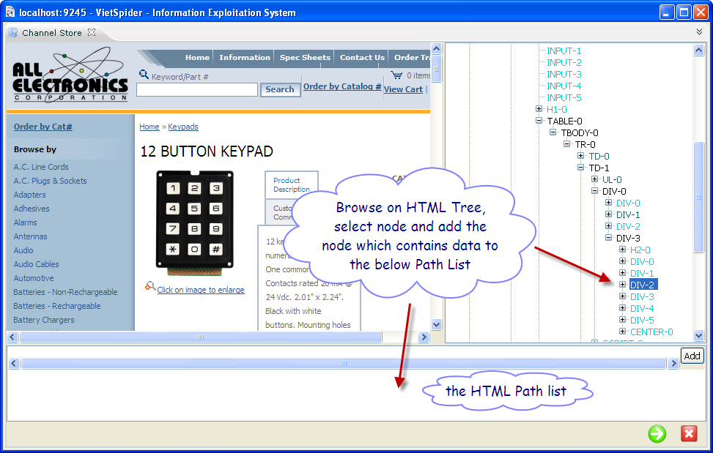

Browse data area of the page by click on the node of HTML Tree

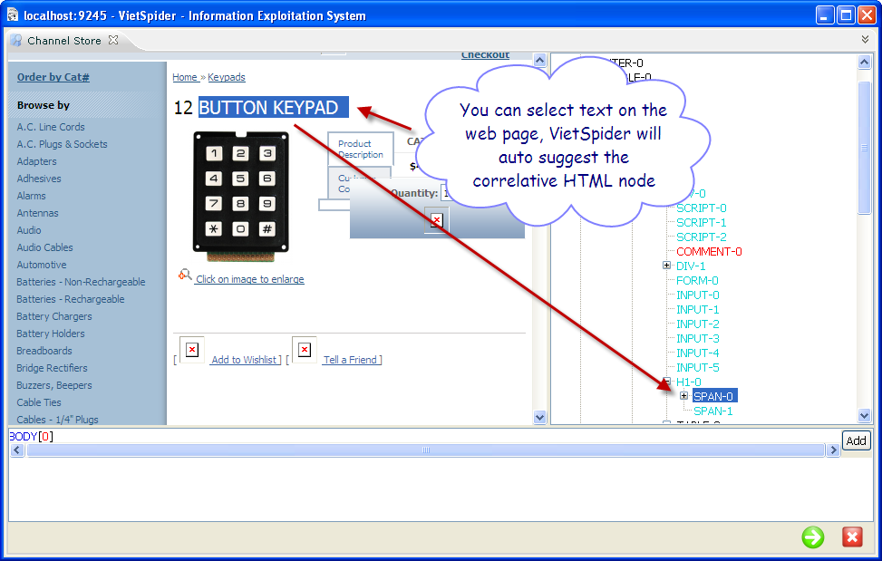

You can select sample text, **VietSpider** will suggest correslative node.

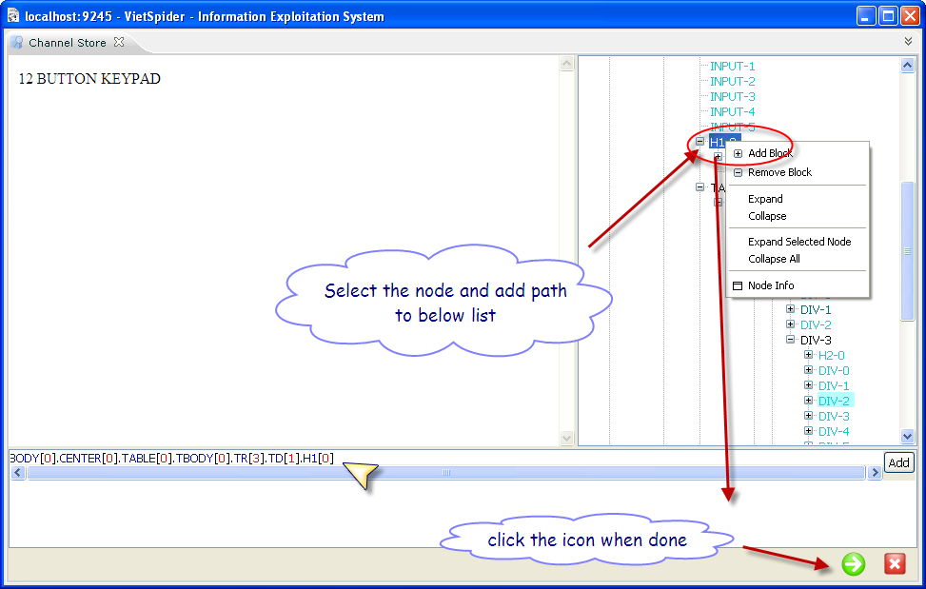

Right click on the node which contains data that you want extract, select **Add Block**.

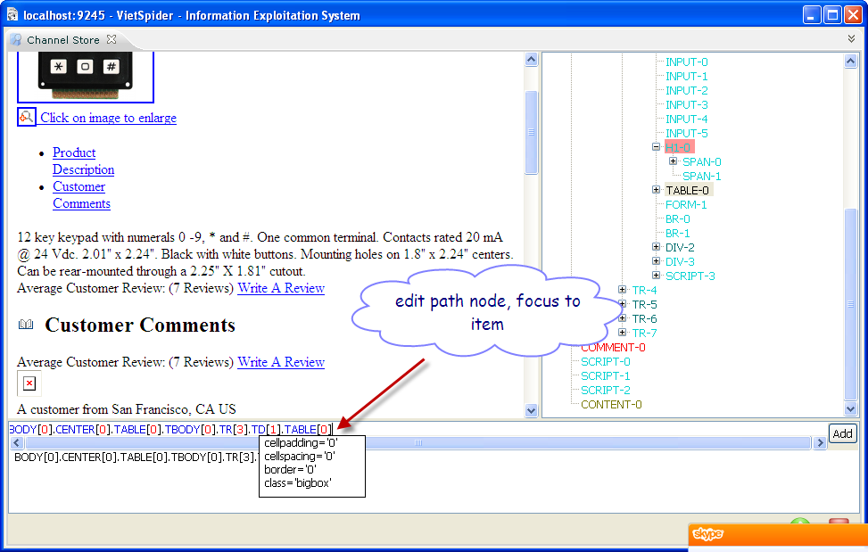

You can edit the HTML node path by focus to a item. Click **Finish** icon when done.

1. **Define XML schema for data document.**

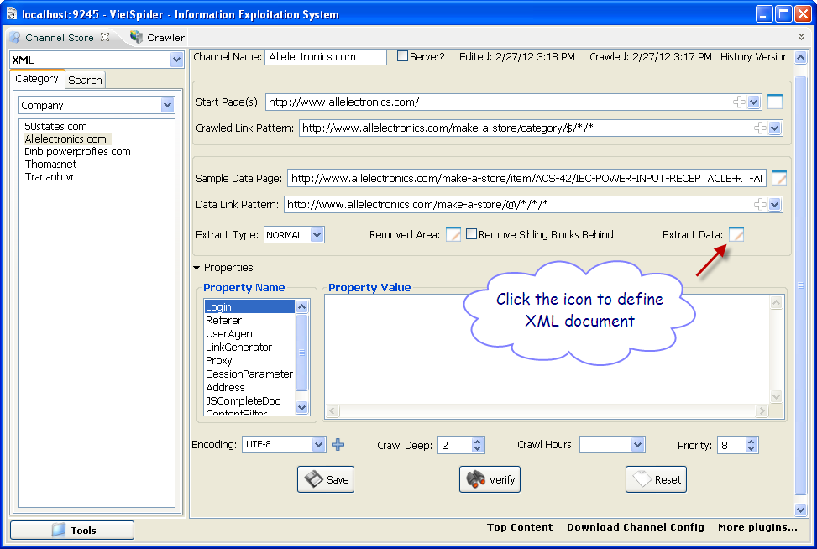

Click on the **Extraxt Data** icon.

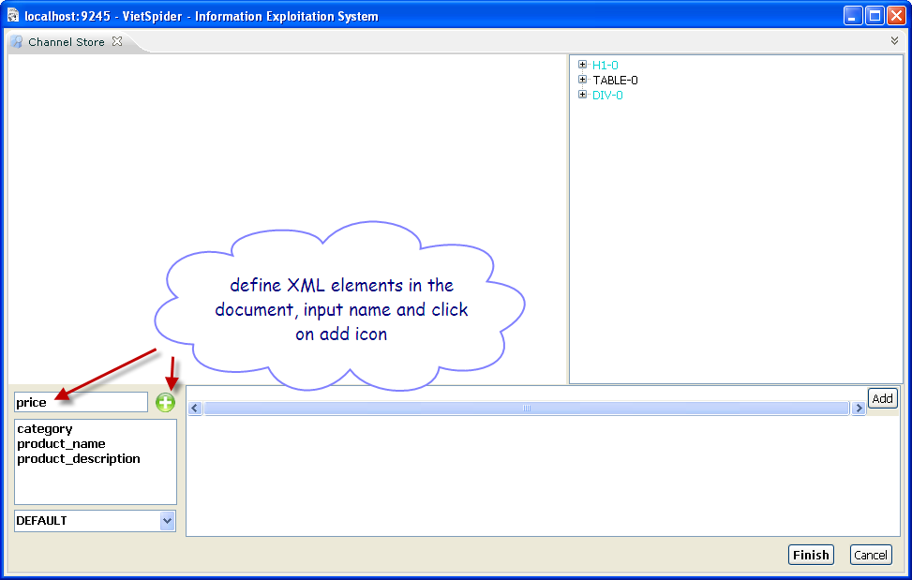

Define XML element of the document by input name and click add icon.

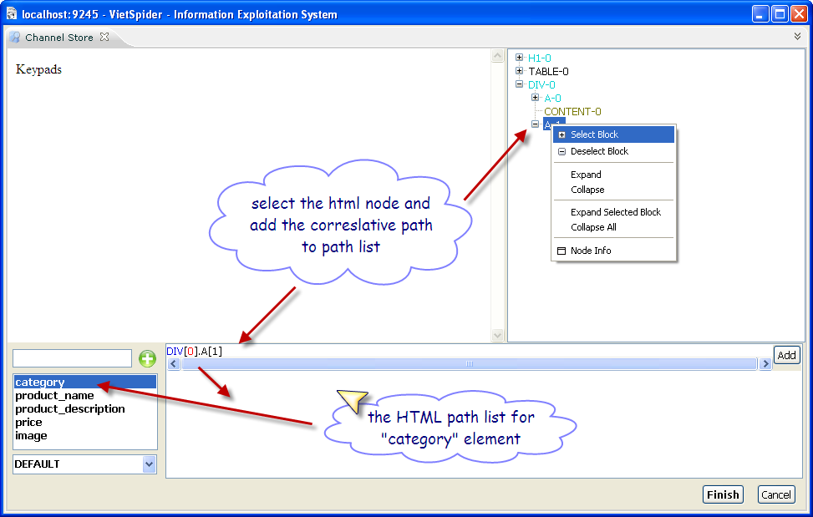

Select element and add data node to the HTML node path list.

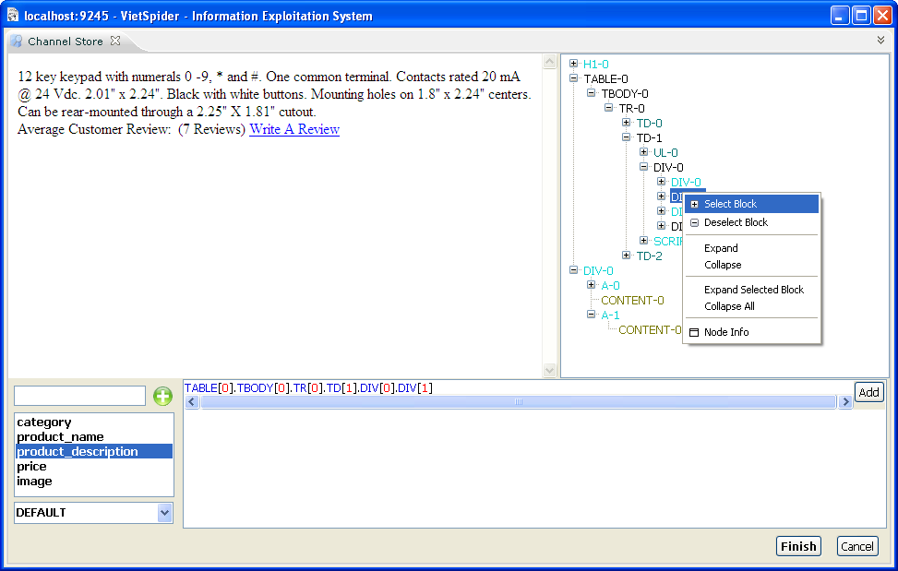

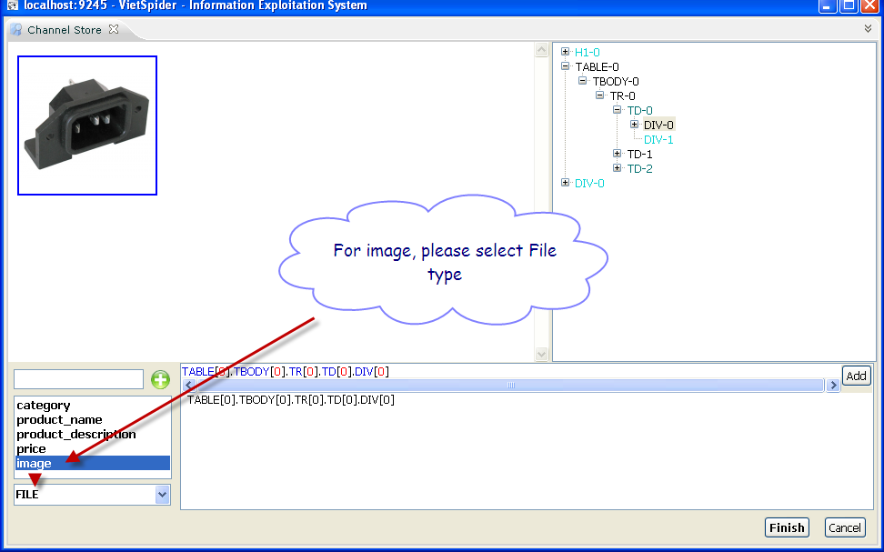

Select data type is **File** if the XML element is image element. Click **Finish** button when done.

1. **Make Crawled Link Pattern(s)**.

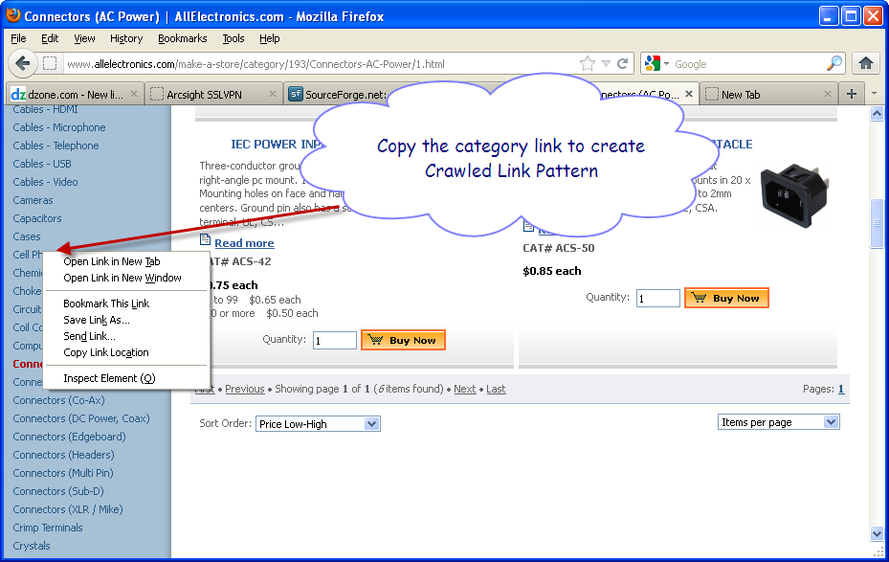

Back to the **Web Browser**, copy a category link.

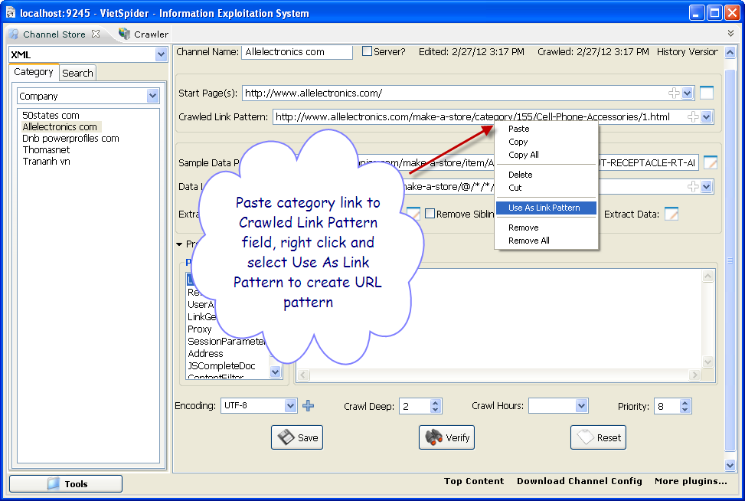

And paste to **Crawled Link Pattern** field to create URL pattern.

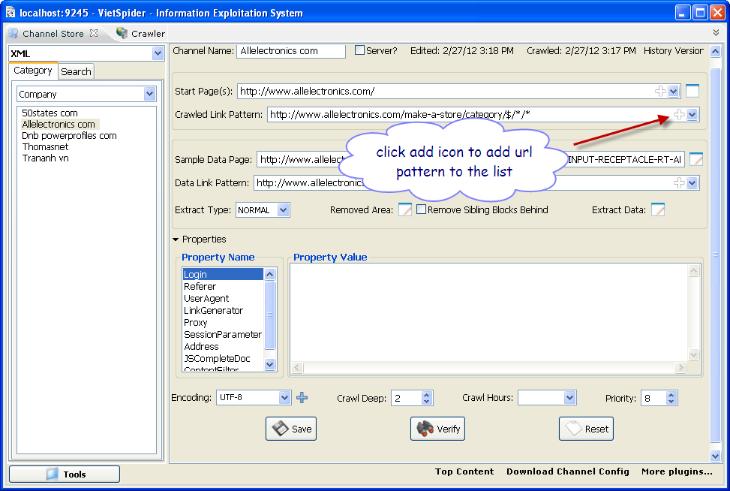

Add url pattern to the list by click on add icon.

1. **Verify the configuration**

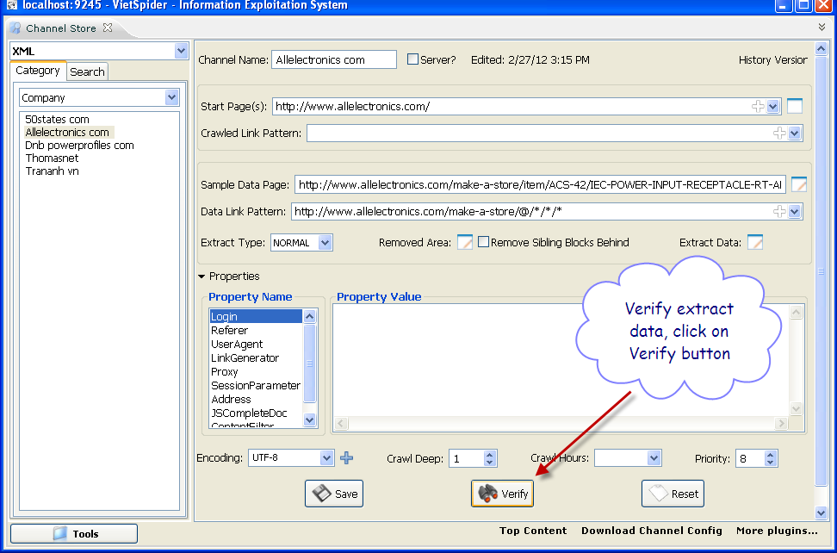

Click on **Verify** button

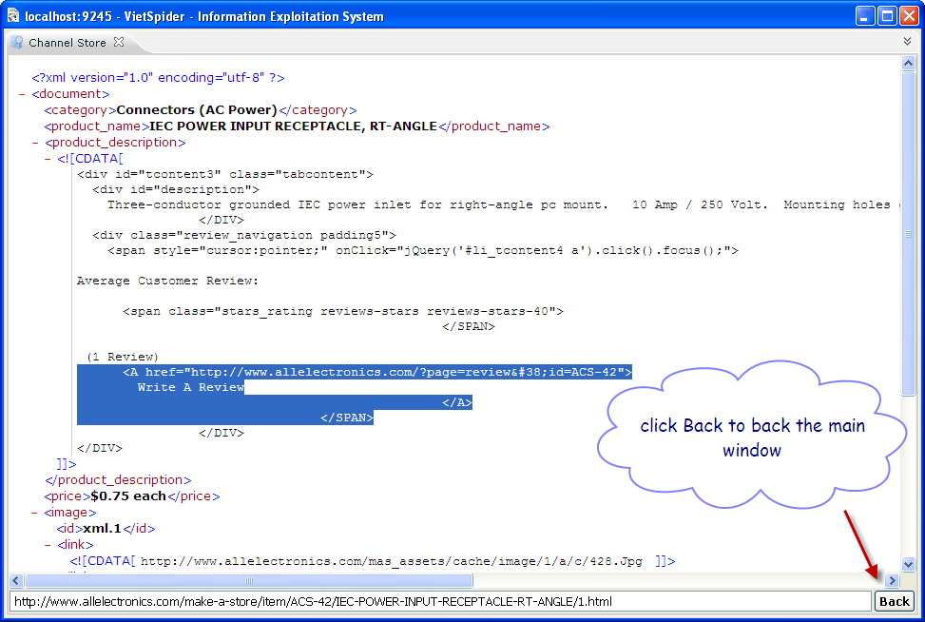

And review sample data after extraction and re-format by XML schema.



Click **Back** button to back to main window.

1. **Start Crawling**

Open **Crawler**, click **Tools** -> select **Crawler**.

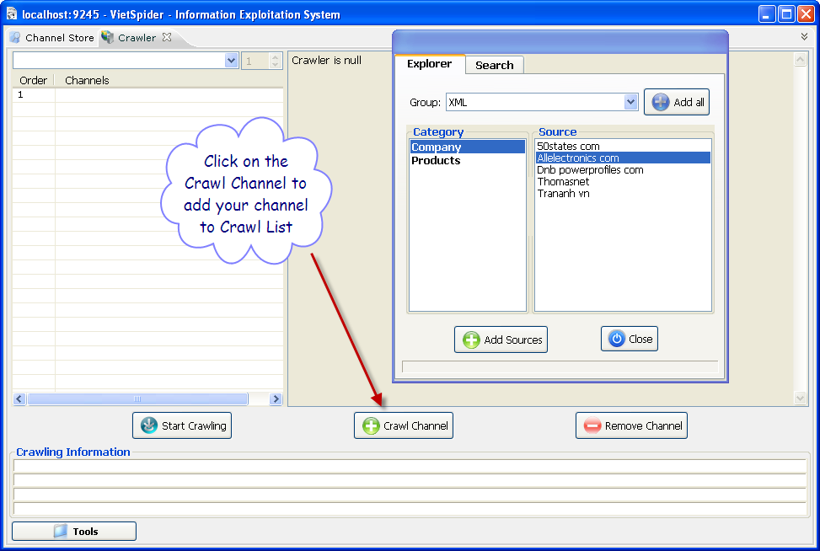

Click **Crawl Channel** button to add the configured channel to crawling list.

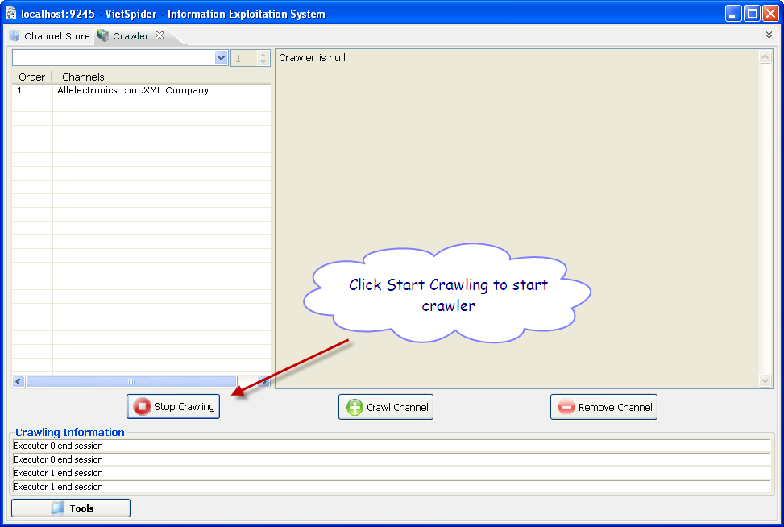

Click **Start Crawling** button to start crawling the channel.

1. **Browse downloaded data**.

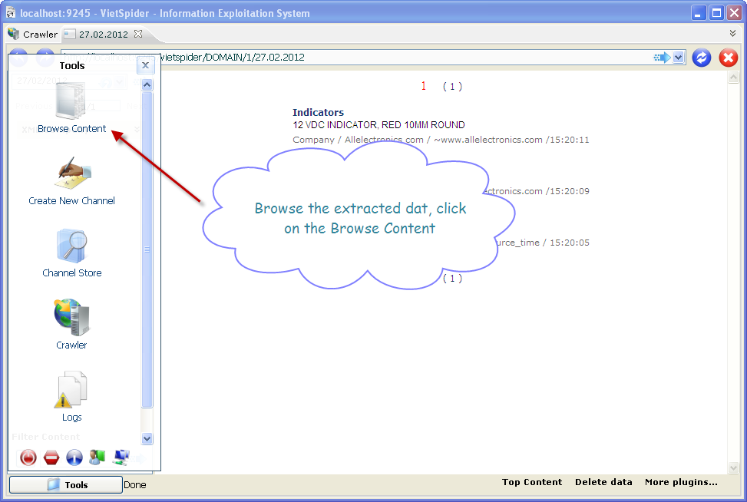

Click **Tools** -> **Browse Content** to browse crawled data.